**Universidad Autónoma de Baja California**

**Facultad De Ciencias Químicas E Ingeniería**



**Graficación**

Metas unidad 4

Soto Elenes Brian Ramiro

Amézquita Becerra Carlos Daniel

Rivera Soto Karen Dayanara

Grupo: 551

Dr. Juan Ramon Castro Rodríguez

Tijuana Baja California a martes, 30 de noviembre del 2021

#1254563 #1262695 #1271872

In [1]:**import** numpy **as** np

**import** matplotlib.pyplot **as** plt

**import** math

In [2]:*#viewProjMatrix.py*

**def** viewProjMatrix(az, el, phi**=**0, target**=**[0,0,0]):

**if** phi**==**0 **and** target**==**[0,0,0]:

phi**=**0

**if** phi**!=**0 **or** target**!=**[0,0,0]:

**if** phi**>**0:

d**=**math**.**sqrt(2)**/**2**/**math**.**tan(phi**\***math**.**pi**/**360)

**else**:

phi**=**0

el**=**((((el**+**180)**%360**)+360)%360)-180

**if** el**>**90:

el**=**180**-**el

az**=**az**+**180

**elif** el**<-**90:

el **= -**180**-**el

az **=** az **+** 180

az **=** az**\***math**.**pi**/**180

el **=** el**\***math**.**pi**/**180

**if** target**!=**[0,0,0]:

**if** len(target)**!=**3:

print('MATLAB:viewProjMatrix:InvalidInput')

**else**:

target[0] **=** 0.5 **+** math**.**sqrt(3)**/**2**\***(math**.**cos(el)**\***math**.**sin(az)) target[1] **=** 0.5 **+** math**.**sqrt(3)**/**2**\***(**-**math**.**cos(el)**\***math**.**cos(az)) target[2] **=** 0.5 **+** math**.**sqrt(3)**/**2**\***(math**.**sin(el))

T **=** [[1,0,0,**-**target[0]],[0,1,0,**-**target[1]],[0,0,1,**-**target[2]],[0,0,0,1]]

R **=** [[math**.**cos(az),math**.**sin(az),0,0],

[**-**math**.**sin(el)**\***math**.**sin(az),math**.**sin(el)**\***math**.**cos(az),math**.**cos(el),0], [math**.**cos(el)**\***math**.**sin(az),**-**math**.**cos(el)**\***math**.**cos(az),math**.**sin(el),0], [0,0,0,1]];

**if** (phi**==**0 **and** target**==**[0,0,0]) **or** phi**==**0:

M**=**R

**return** M

Mwc_vc**=**np**.**dot(R,T)

Tpers**=** [[1,0,0,0],

[0,1,0,0],

[0,0,1,0],

[0,0,**-**1**/**d,1]]

M**=**np**.**dot(Tpers,Mwc_vc)

**return** M

**def** paraboloide(x,y):

**return** (x**\***x **+** y**\***y)

**def** sec(x):

**return** 1.0**/**math**.**cos(x**\***math**.**pi**/**180)

**def** cot(x):

**return** 1.0**/**math**.**tan(x**\***math**.**pi**/**180)

**def** csc(x):

**return** 1.0**/**math**.**sin(x**\***math**.**pi**/**180)

In [3]:*#1A*

Alpha **= -**37.5 *#ZX*

Betha **=** 30 *#ZY*

Phi **=** 0

P **=** np**.**loadtxt('teapot_vertex.dat',unpack**=True**)

M **=** viewProjMatrix(Alpha,Betha,Phi)

Ph **=** np**.**r_[P,[np**.**ones(len(P[0]))]]

Vh **=** np**.**dot(M, Ph)

*# Vertices proyectados en el volumen visual 3D (xp,yp,zp)* V **=** np**.**delete(Vh, 3, axis**=**0) **/** Vh[3]

U **=** np**.**delete(V, 2, axis**=**0)

plt**.**plot(U[0],U[1])

Out[3]:

[<matplotlib.lines.Line2D at 0x218eb74e940>] 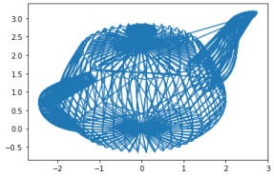

In [4]:*#1B*

Alpha **= -**37.5 *#ZX*

Betha **=** 30 *#ZY*

Phi **=** 10

P **=** np**.**loadtxt('teapot_vertex.dat',unpack**=True**)

M **=** viewProjMatrix(Alpha,Betha,Phi)

Ph **=** np**.**r_[P,[np**.**ones(len(P[0]))]]

Vh **=** np**.**dot(M, Ph)

Out[4]:

*# Vertices proyectados en el volumen visual 3D (xp,yp,zp)* V **=** np**.**delete(Vh, 3, axis**=**0) **/** Vh[3]

U **=** np**.**delete(V, 2, axis**=**0)

plt**.**plot(U[0],U[1])

[<matplotlib.lines.Line2D at 0x218ebecac10>]

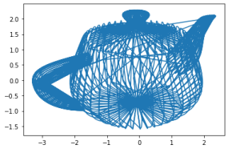

In [5]:*#2A*

Alpha **= -**37.; *#ZX*

Betha **=** 30 *#ZY*

Phi **=** 0

P **=** np**.**loadtxt('bumpy_vertex.dat',unpack**=True**)

M **=** viewProjMatrix(Alpha,Betha,Phi)

Ph **=** np**.**r_[P,[np**.**ones(len(P[0]))]]

Vh **=** np**.**dot(M, Ph)

*# Vertices proyectados en el volumen visual 3D (xp,yp,zp)* V **=** np**.**delete(Vh, 3, axis**=**0) **/** Vh[3]

U **=** np**.**delete(V, 2, axis**=**0)

plt**.**plot(U[0],U[1])

Out[5]:

[<matplotlib.lines.Line2D at 0x218ebf89fd0>]

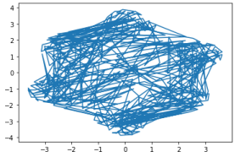

In [6]:*#2B*

Alpha **= -**37.5 *#ZX*

Betha **=** 30 *#ZY*

Phi **=** 10

P **=** np**.**loadtxt('bumpy_vertex.dat',unpack**=True**)

M **=** viewProjMatrix(Alpha,Betha,Phi)

Ph **=** np**.**r_[P,[np**.**ones(len(P[0]))]]

Vh **=** np**.**dot(M, Ph)

*# Vertices proyectados en el volumen visual 3D (xp,yp,zp)* V **=** np**.**delete(Vh, 3, axis**=**0) **/** Vh[3]

U **=** np**.**delete(V, 2, axis**=**0)

plt**.**plot(U[0],U[1])

Out[6]:

[<matplotlib.lines.Line2D at 0x218ebfa65e0>] 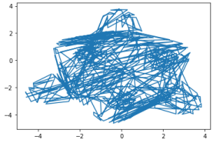

In [7]:*#3A*

Alpha **= -**37.5 *#ZX*

Betha **=** 30 *#ZY*

Phi **=** 0

Out[7]:

X **=** np**.**linspace(**-**5,5,1000)

Y **=** np**.**linspace(**-**5,5,1000)

Z **=** paraboloide(X,Y)

P **=** np**.**array([X,Y,Z])

M **=** viewProjMatrix(Alpha,Betha,Phi)

Ph **=** np**.**r_[P,[np**.**ones(len(P[0]))]]

Vh **=** np**.**dot(M, Ph)

*# Vertices proyectados en el volumen visual 3D (xp,yp,zp)* V **=** np**.**delete(Vh, 3, axis**=**0) **/** Vh[3]

U **=** np**.**delete(V, 2, axis**=**0)

plt**.**plot(U[0],U[1])

[<matplotlib.lines.Line2D at 0x218ebffd370>]

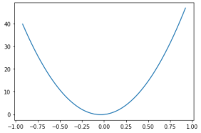

In [8]:*#3B*

Alpha **= -**37.5 *#ZX*

Betha **=** 60 *#ZY*

Phi **=** 10

X **=** np**.**linspace(**-**5,5,1000)

Y **=** np**.**linspace(**-**5,5,1000)

Z **=** paraboloide(X,Y)

P **=** np**.**array([X,Y,Z])

M **=** viewProjMatrix(Alpha,Betha,Phi)

Ph **=** np**.**r_[P,[np**.**ones(len(P[0]))]]

Vh **=** np**.**dot(M, Ph)

*# Vertices proyectados en el volumen visual 3D (xp,yp,zp)* V **=** np**.**delete(Vh, 3, axis**=**0) **/** Vh[3]

U **=** np**.**delete(V, 2, axis**=**0)

plt**.**plot(U[0],U[1])

print(M)

[[ 0.79335334 -0.60876143 0. -0.09229596]

[ 0.52720286 0.68706415 0.5 -0.4241208 ]

[-0.30438071 -0.39667667 0.8660254 -0.83248401]

[ 0.03766031 0.04907987 -0.10715129 1.10300129]]

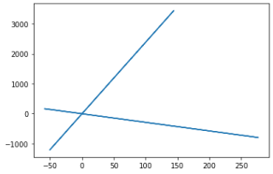

In [9]:**def** Mnormsymmpers(theta, Znear, Zfar, aspect):

MNmatrix **=** [[cot(theta**/**aspect), 0, 0, 0],

[0, cot(theta**/**2), 0, 0],

[0, 0, (Znear **+** Zfar)**/**(Znear **-** Zfar), (2 **\*** Znear **\*** Zfar)**/**(Znear **-** Zfar) [0, 0, **-**1, 0]]

**return** MNmatrix

In [10]:*#4*

theta **=** 180

Znear **=** 1

Zfar **=** 10

aspect **=** 1

P **=** np**.**loadtxt('teapot_vertex.dat',unpack**=True**)

M **=** Mnormsymmpers(theta, Znear, Zfar, aspect)

Ph **=** np**.**r_[P,[np**.**ones(len(P[0]))]]

Vh **=** np**.**dot(M, Ph)

*# Vertices proyectados en el volumen visual 3D (xp,yp,zp)*

V **=** np**.**delete(Vh, 3, axis**=**0) **/** (Vh[3]**+**1**/**1000)

U **=** np**.**delete(V, 2, axis**=**0)

plt**.**plot(U[0],U[1])

Out[10]:

[<matplotlib.lines.Line2D at 0x218ec138d00>]

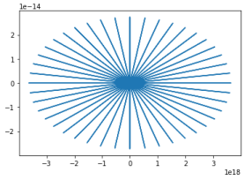In [ ]:

In [ ]: